Stone-X™
Countertop Cleaner

A. Simply spray Stone-X™ onto the stone surface.

B. With a clean, dry terry cloth or paper towel, wipe off Stone-X™ from surface.

C. Clean surfaces as frequently as daily or weekly.

Stone-X™ is a cleaning agent, it is not intended for stain removal purposes*.

*Existing stains must be removed prior to beginning the Felixchem Care Program. Felixchem offers poultice products for stain removal purposes. Should you have any questions about care and maintenance for your natural stone, please call Customer Service:
1(888) 319-0141 or email us at: products@felixchem.com.

Strongman-W ™
Stone Sealer

A. Remove all stains prior to sealing the surface*. Surface should be kept dry and clean 6-12 hours prior to sealer application.

B. Cover all areas that you don’t intend to be sealed

C. Spray the Strongman-W Sealer™ on the surface and saturate the entire surface.

D. When surface begins to dry within 3-5 minutes, wet the surface again with the sealer. (If Sealer is absorbed within 5 minutes, apply one more spray coating.)
E. After ONE HOUR, wipe off excess sealer with a clean and dry white terry cloth towel.
F. if excess dries on the surface, spray more sealer onto the surface and wipe off immediately.
F. Do not let the stone surface get wet for 24-48 hours after the Strongman-W Sealer™ application.
G. Sealing with Strongman-W Sealer™ should be applied once a year and anytime the surface has been scoured by abrasive materials, in order to prevent staining and/or mildew growth.

Use on stone and grout only.

Polish-X™
Countertop Polish

A. Shake the bottle before using. Apply
the Polish-X™ to the surface with a clean,
dry, white terry cloth towel.

B. Let the Polish-X™ dry to a haze for 2
minutes.

C. Wipe off the haze with a clean, dry,
white terry cloth towel.

D. Repeat process with Polish-X™
weekly to enhance the beauty and enrich
the crystalline colors of your natural stone
countertops.

Not for use on floors.

What you should know about natural stone maintenance. . .

Natural stones are sensitive to alkali and acidic cleaners such as all-purpose and industrial cleaners. Non-specialized cleaners can cause deterioration and corrosion of the bonding agents within the stone’s crystalline structure.
Stone-X™ Countertop Cleaner:
- 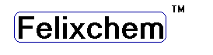ph7 balanced formula
- ready-to-use (no mixing required)
- leaves surfaces streak-free
- effectively cleans by penetrating and dissolving oil and greasy residues
- safe to use on food handling surfaces

Mineral surfaces are porous and act like a sponge in the presence of moisture and liquids. Without proper sealing, oil, dirt, acidic and alkali liquids, can infiltrate into the stone causing corrosion, staining, and discoloring.
Strongman Sealer-W ™ Stone Sealer:
- penetrates, protects and bonds to the interior of the stone’s surface, thus preventing contaminants from being absorbed
- allows stone to breath and release moisture vapors
- exceeds ADA standards for slip resistance, UL Classified for Slip resistance
- prevents growth of bacteria, mold, and mildew

Polish-X™ Countertop Polish:
- provides a protective coating which polishes and enhances the brilliant colors of natural stone

Preventive care and maintenance should start as soon as surfaces are installed.

Your natural stone is a valuable investment, show it off!

Ph: (888) 319-0141 Fax: (888) 319-0142

www.felixchem.com

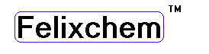

© 2003 Felixchem Corporation, Inc.

Caring for your natural stone
surface is as easy as

. . . 1 , 2 , 3 !

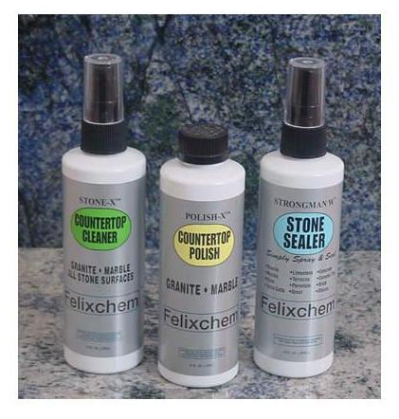
www.felixchem.com

